Wallet Friendly Hunger Busters Chicken Snack Wraps $2.65 Hot Dog $2.65
Grilled Cheese $3.20 Fries $3.20
Cheese Pizza Slice $3.20


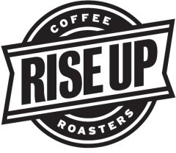
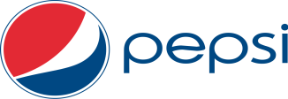



Fall 2026 - Spring 2027
All Prices Include Tax
12 oz / 16 oz
Rise Up Coffee
$3.25 / $3.75
Cappuccino
$3.25 / $3.75
Hot Chocolate
$3.25 / $3.75
Hot Tea
$1.05 per tea bag
Aquafina Water
$1.35
Assorted 12 oz Canned Beverages
$1.35
Propel
$3.20
Assorted 20 oz Bottled Beverages
$3.20
Bottled Tea
$3.20
Bottled Juices, 10 ounce
$2.15
Gatorade
$3.20
Hi-Energy Drinks
$4.25
Assorted Fountain Beverages
24 oz Medium $1.90
32 oz Large $2.25
All prices include tax.

Monday-Thursday
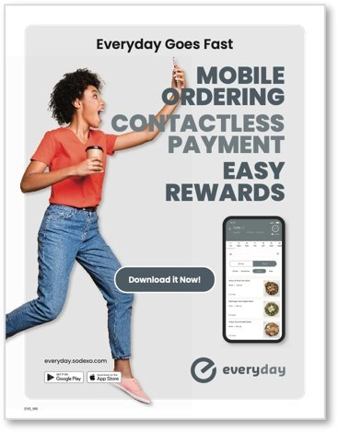
8am—2pm Friday
8am - 1:30pm
holiday hours vary
Grab and Go with a variety of hot
and cold selections
or
Made-to-Order using the everyday app or in the café by order form

Daily specials!


Located on the first floor of the Hazel Center.

SOGO Cash Cards
Sodexo Café cash cards offer convenience and simplicity!
No expiration date! No fees!
Now available to purchase with financial aid.
Great gift for students or coworkers!
Reload in the café or online.
Learn more at www.sogocashcard.com



Effective 9/1/26




Grill

ALL PRICES INCLUDE TAX
Hamburger
$5.30
Cheeseburger
$5.80
Bacon Cheeseburger
$6.90
Double Cheeseburger
$8.50
Garden Spicy Black Bean Burger (vegetarian) $5.80
Philly Cheesesteak
$8.50
Fish Sub (flounder)
$7.70
Hot Dog
$2.65
Fries
$3.20
Sweet Potato Fries
$4.25
Onion Rings
$4.25
Mozzarella Sticks (6) w/ marinara
$7.95
Breaded Cauliflower (vegetarian)
$4.25
Chicken Tenders (3)
$6.90
Crispy Chicken Sandwich
$6.35
Grilled Chicken Sandwich
$6.35
Chicken Snack Wrap
$2.65
Grilled Cheese
$3.20
Pepperoni Bagel
$4.75
Pizza
Cheese Pizza $3.20 Slice Pizza w/ Toppings $4.05Slice
Personal Naan Bread Pizzas $6.35
(Made to order w/ choice of toppings)
Breakfast
ALL PRICES INCLUDE TAX

Sandwiches Made to Order: $4.25
Choice of bread, meat, cheese, two eggs

Grab and Go :
English muffin or biscuit, one egg, cheese $3.20
Sausage or bacon, on an English muffin
or biscuit, and cheese
$3.20
Download the EVERYDAY App for a
larger breakfast menu!
Deli

ALL PRICES INCULDE SALES TAX
Choice of 6” sub roll, assorted breads, wraps, gluten-free bread, or lettuce wrap
Egg Salad $4.75
Veggie $4.25
B.L.T. Sandwich $5.30
Ham & Cheese $6.35
Turkey & Cheese $6.35
Chicken Salad $6.35
Italian Sub or Wrap $6.65
Or build your own sub/wrap/sandwich with choices of breads, meats, cheeses, condiments, and veggies.

Salads
Small Salad
Small Salad w/ Cheese Large Garden Salad
$5.30
$5.80
$9.55
Small Salad w/ Protein
$8.50
Large Salad w/ Protein
$11.65
Protein Options: Ham, Turkey, Grilled Chicken, Crispy
Chicken, Chicken Salad, or Egg Salad
This document is available in alternative formats to individu-als with disabilities by contacting disability services

at disabilityservices@worwic.edu, 410-334-2899 or TTY 410-767-6960. Wor-Wic Community College is an equal op-portunity educator and employer.
Grab & Go
In A Hurry?
Stop by for a selection of freshly made items ready to go!
In the cooler:
Assorted Sandwiches Specialty Salads Fresh Snacks
Fruit Desserts
In the hot slide during peak lunch rush:
Cheeseburgers Hamburgers
Chicken Tenders

Visit www.worwic.edu/Services-Support/Disability-Services to learn more.

